* **Install PostgreSQL step by step**
  + Link to get the pgAdmin: <http://www.enterprisedb.com/products-services-training/pgdownload>
    - Please choose the version according to your OS
  + Double click on the installer file, an installation wizard will appear and guide you through multiple steps where you can choose different options that you would like to have in PostgreSQL.
  + Enter the password for the database which is “password”(without the quotation)
    - * 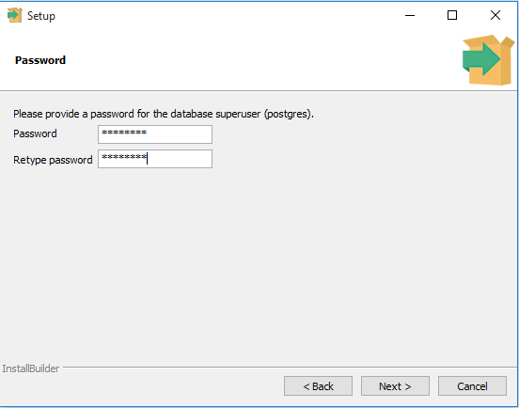
      * **Note: If you are using other password, please remember the password you created in order to connect the code to the Database**
  + Enter the port for PostgreSQL, which is 5433 instead of 5432.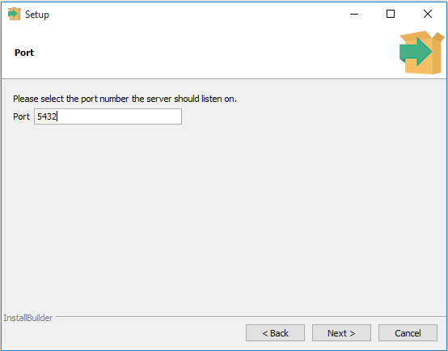
    - * **Note: If you are using another port other than 5433, please remember the port number in order to connect the code to the Database**
  + Choose the default locale used by the database.
    - 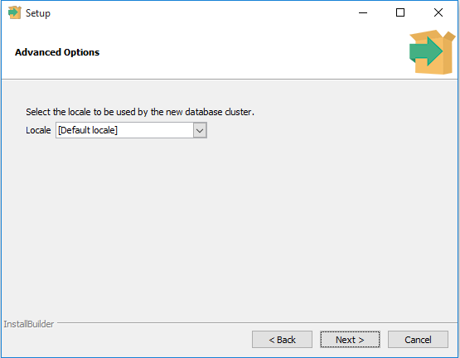
  + You’ve completed providing information for the PostgreSQL installer. Click the Next button to install PostgreSQL
    - 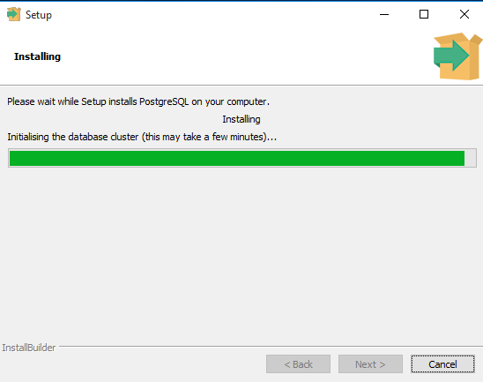
    - The installation may take few minutes to complete.
  + Click the Finish button to complete the PostgreSQL installation.
    - 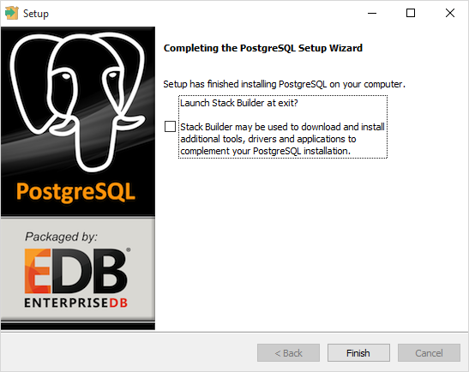
  + Verify the Installation:

.

* + - First, click on pgAdmin III to launch it. The pgAdmin III GUI will display.
      * 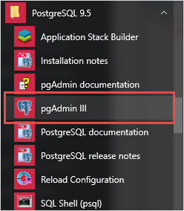
    - Second, double click on**PostgreSQL 9.5** on the object browser. It will ask you for the admin password. Just enter the password you’ve used in the installation step.
      * 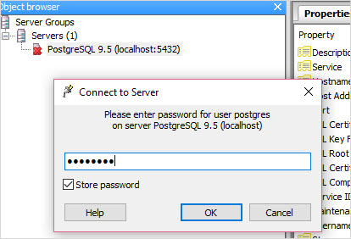
    - Third, if everything is fine, the pgAdmin will display all the objects that belong to the server. The picture below shows what happen if you login successfully
      * 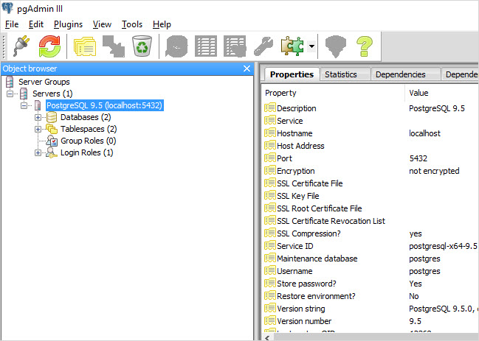
* **Restoring the Database**
  + Download the database(https://drive.google.com/open?id=1K6dTI3y5hqBjTy_XbzhamtGOab_i4k4D)
  + Double click on**PostgreSQL 9.5** on the object browser in order to connect. You should see Databases as one of the drop down menu
  + From the Databases, right mouse click and chose the New Databases… A new window will appear.
    - 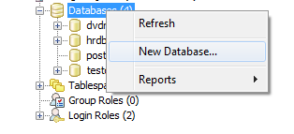
  + Third, enter the database name which is Book in Name and click OK
    - 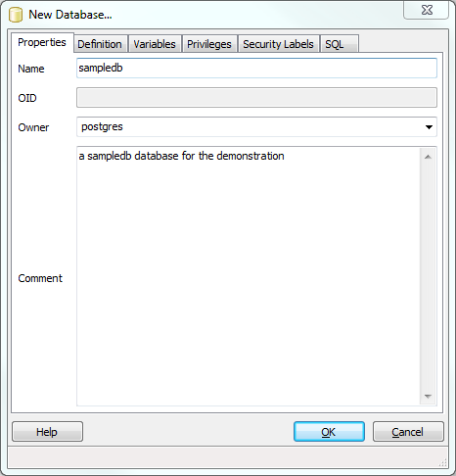
    - **Note: If you give another name to the database, please remember the name you created in order to connect the code to the Database**
  + In the main GUI window, click refresh(the icon circled) and you should see Book shown as a database
    - 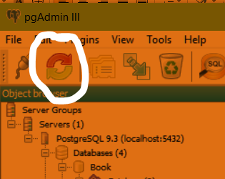
  + Right click on the Book database and click restore
    - 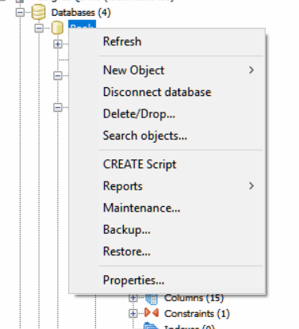
  + In the popup window, change the file name to the path where you saved the downloaded database and click restore.
    - 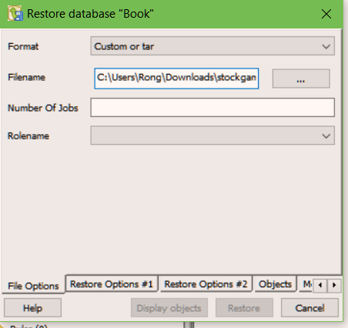
  + Another window should appear and start the restore process. The process is done when the line “Process returned exit code 1” shows up.
    - 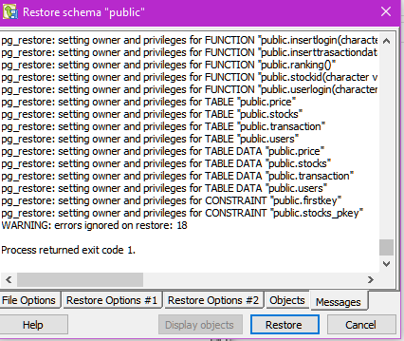
  + Check your database is updated by first clicking on the Databases and then click on connect (circled in red in figure below) .You should see Book under the drop down menu from Database. Click on the Book and you should see one of the options is Schemas. Under the public section of Schemas, you should see Functions (8) like the figure below. This means you have the most recent database.
    - 